# *Applied Mathematics for Informatics*

# *Seminar 12*

**Decision Models (****certainty, uncertainty and risk)**

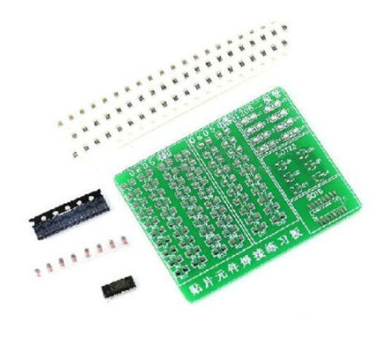**Strategy selection**

A company engaged in the production of sets for mastering basic operations with SMD components can produce three variants of sets (A, B, C - see assignment of past exercises).

This time, the company is in a situation where it has to make a decision about which types of sets to produce and offer to high schools and universities of electrical fields and fields focused on industrial automation, given the market situation. However, the situation in the market for these teaching sets is uncertain, so the demand for these products can range from very low, through medium to very high.

Estimated sales (in millions of CZK) for the production of teaching sets, depending on demand, are shown in the following table:

|  |  |  |  |  |  |
| --- | --- | --- | --- | --- | --- |
|  | Very low | low | medium | high | Very high |
| Sada A | 0,1 | 0,2 | 0,5 | 0,7 | 0,9 |
| Sada B | 0,05 | 0,15 | 0,5 | 0,75 | 1 |
| Sada C | 0,05 | 0,15 | 0,5 | 0,75 | 1 |
| Sada A+B | 0,15 | 0,35 | 1 | 1,45 | 1,9 |
| Sada B+C | 0,1 | 0,3 | 1 | 1,5 | 2 |
| Sada A+C | 0,15 | 0,35 | 1 | 1,45 | 1,9 |
| Sada A+B+C | 0,2 | 0,5 | 1,5 | 2,2 | 2,9 |

The average production cost of one set of any kind is 0.1 million CZK. If the company wants to produce two types of sets at the same time, it has to invest and expand the production line, and therefore the average production costs of the two types of sets are CZK 0.4 million. If the company decides to produce all types of sets at the same time, it must build new production premises, and therefore, after accounting for additional costs, the average production costs for the production of all three types of sets are 1 million CZK.

**Part A Tasks and questions:**

1) Define a set of alternatives.

2) Define a set of states of nature.

3) Build a payoff matrix.

4) Build a decision tree.

5) Assess the dominance of individual alternatives (according to payouts, according to the state of nature, according to probability - risk profile, fill in the missing data yourself).

**Part B**

**Tasks and questions:**

1) Decide what types of sets (or their combination) to produce in the case of decisions based on certainty, uncertainty and risk (fill in the missing data yourself).

2) Interpret and compare the achieved results.